1.

<https://testeroneit.atlassian.net/secure/RapidBoard.jspa?projectKey=CAL&rapidView=1&selectedIssue=CAL-2>

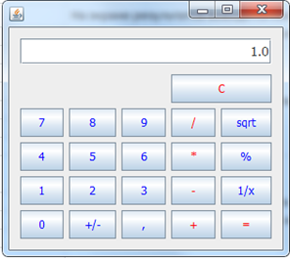

2.

<https://testeroneit.atlassian.net/secure/RapidBoard.jspa?projectKey=CAL&rapidView=1&selectedIssue=CAL-3>

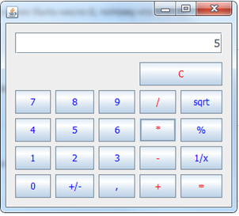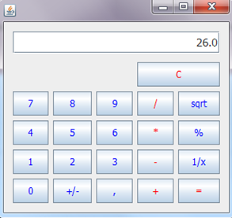

3.

<https://testeroneit.atlassian.net/secure/RapidBoard.jspa?projectKey=CAL&rapidView=1&selectedIssue=CAL-4>

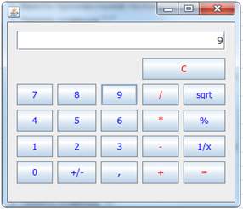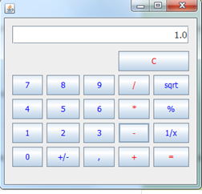

4.

<https://testeroneit.atlassian.net/secure/RapidBoard.jspa?projectKey=CAL&rapidView=1&selectedIssue=CAL-5>

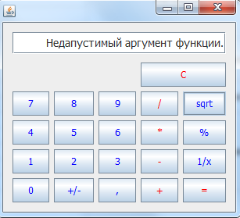

5.

<https://testeroneit.atlassian.net/secure/RapidBoard.jspa?projectKey=CAL&rapidView=1&selectedIssue=CAL-6>



6.

<https://testeroneit.atlassian.net/secure/RapidBoard.jspa?projectKey=CAL&rapidView=1&selectedIssue=CAL-7>

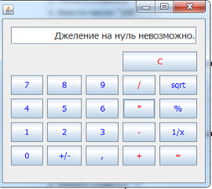

7.

<https://testeroneit.atlassian.net/secure/RapidBoard.jspa?projectKey=CAL&rapidView=1&selectedIssue=CAL-8>

8.

<https://testeroneit.atlassian.net/secure/RapidBoard.jspa?projectKey=CAL&rapidView=1&selectedIssue=CAL-9>

